# APF Script

# Application and Set Up Guide

Version No: 11.0

# Prepared by: Nikki Bromwich

# Date: 06 April 2012

Table of Contents

Purpose of the Document 3

Prerequisite 3

Installation 3

*1.1* *Setup Preparation Screen* 3

*1.2* *Welcome Dialog Box* 4

*1.3* *Installation Status* 5

*1.4* *Installation Confirmation* 5

Set Up 6

How to run the APF script 6

# Purpose of the Document

This document is the installation and Set Up Guide for the APF Script V11.0. It describes in detail the steps involved to Install and set up the application.

# Prerequisite

* Galileo Desktop Version minimum version 1.x or above
* Windows® 2000 SP3, Windows® NT Service Pack 6a, Windows® Me and Windows® XP or Higher.
* Microsoft® Internet Explorer 6.0 or Higher

# Installation

Double click on the executable file. 

## *Setup Preparation Screen*

This shows the setup wizard preparation screen to prepare the APF script for setup.

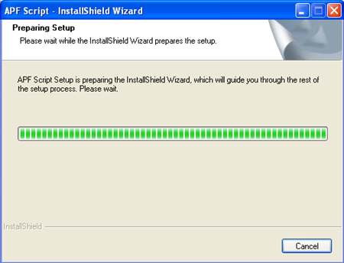

If you have a previous version of the script installed you will prompted to remove this prior to installing the new one.

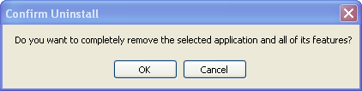

Once the old version of the script has been removed, the following confirmation screen will be displayed.

Click **Finish**

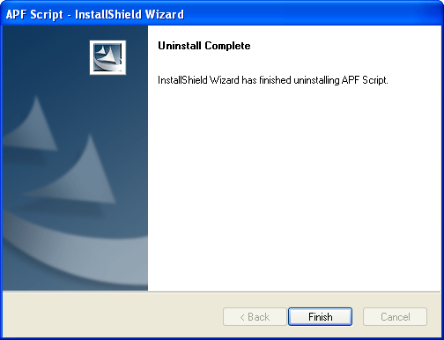

Double click on the executable file. 

## *Welcome Dialog Box*

Click **Next>**

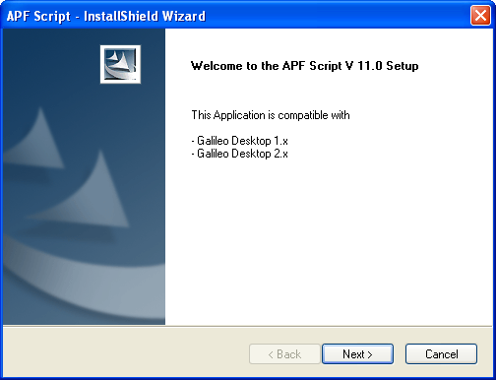

## *Installation Status*

Shows the status of the installation

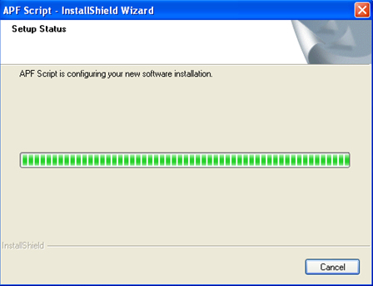

## *Installation Confirmation*

Confirm the script has been successfully upgraded. Click **“Finish”** to exit the wizard.

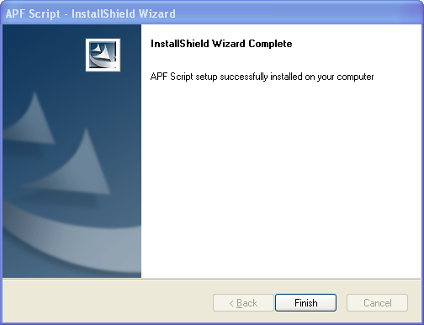

# Set Up

The APF Script will be installed in the CustomViewpoint Folder on the C drive. It is made up of the following files/folders, which run the application therefore please do not delete or move any of these files. The debug log is used for support purposes and will be discussed in the support guide.



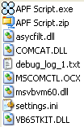

# How to run the APF script

Once the installation is complete an icon will appear on Gal Desktop.

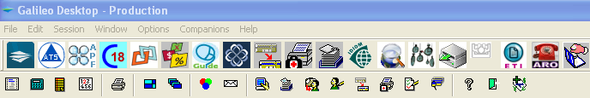

For details of how to use the application please refer to the user guide.